Tayar Nepal PROGRAM
Report on Completion of Roadside plantation work
[ Resham Nepali] For USAID
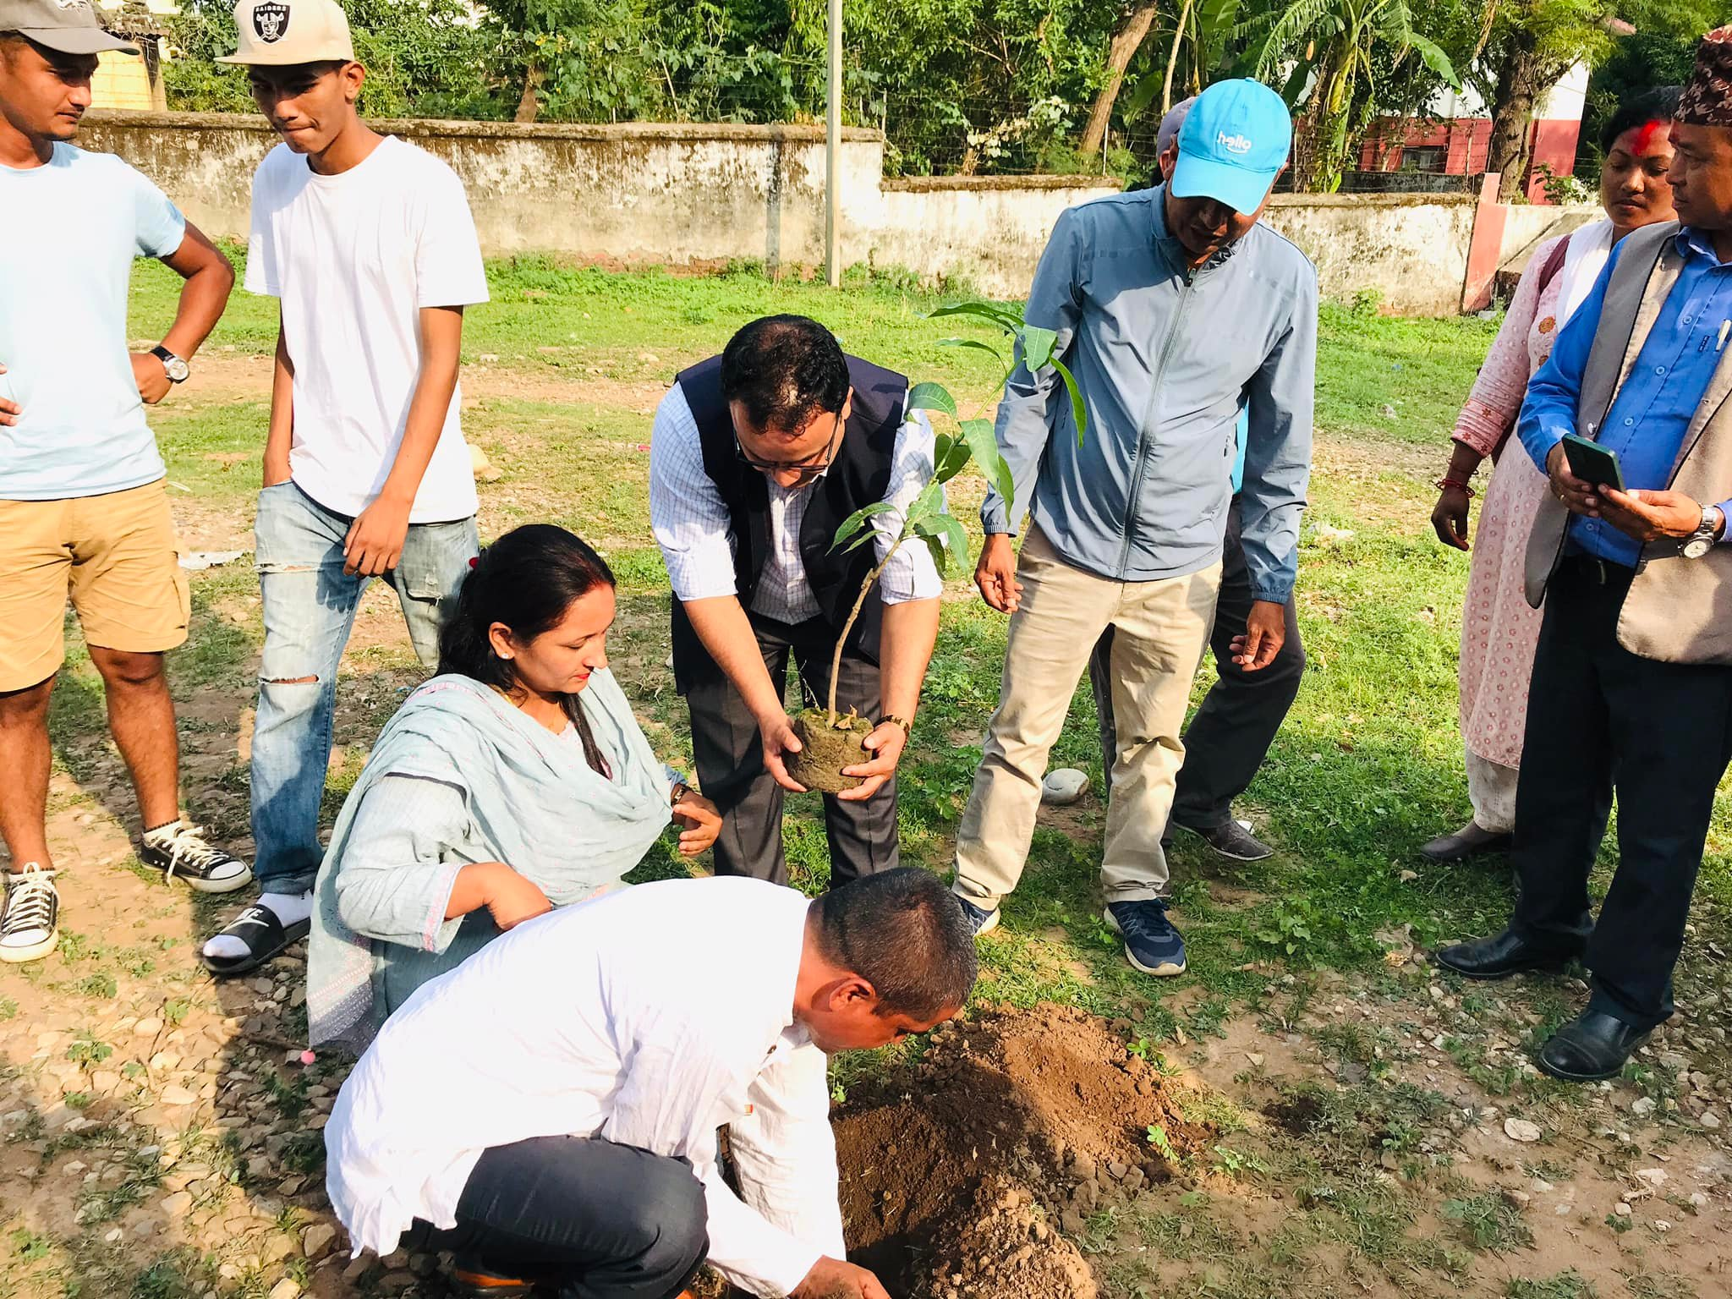
  - July 7, 2022

Cover photo: [Planting tree by Mayor Mrs. Mohanmaya Dhakal and Head of Admisnistration of Bitrendar nagar MUnicipality Mr. Narhari Tiwaree ]
Photo credit: [Resham Nepali] for USAID Tayar Nepal

TayarNepal PROGRAM
Inception Report

Program Title: Roadside plantation, Installation of waste Collection Bin and Resting Station in Birendranagar
DAI Project Number: 1003907-s21-0012-00

Sponsoring USAID Office: USAID/Nepal

IDIQ Number: XX

Task Order Number: XX

Contractor: DAI Global LLC

Date of Publication: [insert]

author: [insert]

Contents
Executive Summary 3
Background and project Information 3
Objectives 3
Literature review 4
Methodology and Approach 4
Strategic location for plantation, waste bin and resting station 5
Coordination mechanisms 6
Detail action plan( Table no 1 ) 6
Progress update 7
Complete activities 7
Program orientation: 7
Feasibility study: 7
Meeting with District Forest Office: 9
Quality assurance plan( Table no 5 ) 9
Human resource details 10
Annex : 11
Photos: 11
Participant list of orientation and feasibility study: 12

Executive Summary
To promote the climate resilient, waste management and provide service to passer-by for rest, Interdependent Society Surkhet ( ISS ) is implementing Program as a sub-contractor for USAID/Tayar Nepal for " Improved Disaster Risk Reduction Project to implement Roadside plantation, Installation of Waste Collection Bin and Resting Station in Birendranagar Municipality "with period of 17 February 2022 to 30 June 2022 This program is focused at ward 6, 7 and 8 at Birendranagar Surkhet.

The key action under project is to promote climate resilient through plantation of 1,000 plants of fruits and flowers which contribute on climate change, establish local enterprises as well as contribute to develop green city as per municipal agenda. In addition, project also aims to support in sanitation and biodiversity through installation of 100 waste collection bin to reduce, recycle and reuse of generated waste by local community and installation of 20 resting station to provide resting service to passer to give service to children, traveler, elderly citizen, and tourist at the time of sunny day, and monsoon.

This report covered period of May 15 to Jun 30, 2022 about the completion of Roadside Plantation Work. ISS had started the plantation in May 15, 2022 at ward 8, Kalinchowk , Birendranagar Municipality in the presence of Mr. Dev Kumar Subedi Mayor of BNNP. ISS had target to plant 1000 trees in ward 6, 7 and 8 in Birendranagar. So ISS had successfully planted 1000 plants of fruits, herbal and floral in diffrenets areas of ward 6, 7 and 9 and completed plantation by Jun 30, 2022. Inner Wheel Club of Surkhet District, Mega Bank Surkhet Branch, Gurukul Montesory and Peace Land Guest House are involved as private sector for adopting the plants.

Background and project Information
Global warming is being a big challenge all over the world. The growing incidents of climate induced disaster and global warming is creating threats to the entire eco-system including human beings. The magnitude of the disaster is amplified in poor counties due to multiple factors like rapid and unplanned urbanization, lack of building codes implementation, inadequate disaster preparedness, increase in slums and squatters, inadequate housing, services, and infrastructures and loss of biodiversity, pollution and many others jeopardizing development gains and increasing vulnerability. According to Intergovernmental panel on climate change (IPCC) report, cities consume 75% of the natural resources and 80% of the global energy supply and produce 70 % of global carbon emissions. In regard to actions for combating the impacts of climate change and global warming, tree plantation is one of the simple but most effective ways. Apart from carbon sequestration, trees also absorb various harmful gases including sulphur dioxide and carbon monoxide and filter harmful pollutants from the atmosphere and provides fresher and cleaner air to breathe. Some of the top advantages of growing trees include getting oxygen, clean the air, control of air and noise pollution, functioning as windbreaks, enhance beauty, health, and liability aspects of cities, providing habitat to wildlife, yielding fruits and medicinal plants and many more. All these cumulates to reduce the impacts of climate change and global warming. According to Forest Division Office Surkhet, one tree can produce 16 kg oxygen and can absorb 47 kg of carbon dioxide and helps mitigate the impacts of climate change. In long run, it helps to vulnerability of disaster impacted communities with reduced incidents of climate induced disaster

Birendranagar is in Karnali province, it is one of the fastest urbanizing cities of Nepal and with the declaration of capital of Province 6 after federalization in Nepal. Birendranagar is a hub city, where people come here form different districts for the purpose of study, business, and other facilities. It has been a point of attraction to people which is causing high population. With the increasing number of people and rapid urbanization, Birendranagar is facing challenges on solid waste management, water pollution, air pollution, encroachment of natural and sensitive environmental areas, natural resource depletion and the growing impacts of recurring disaster and climate change etc. With increasing urbanization, amount of waste is also increasing. Waste management is becoming a big challenge because of not properly implementation of rules and regulation on waste management, not having proper place for waste management, not waste segregating practice, not collecting regular waste from household by private sector. So that people are throwing waste on the road, bush, and field. There is lack of awareness among people on waste management. Municipality installed dustbin properly, however, dustbin is being damage, not collecting the waste from dustbin time are the challenges for waste management. During raining season, summer season or other days, there is no resting space for traveler / passerby. In such case, traveler used to take rest inside the shop, most of the shop do not welcome to traveler, it's been hard to travel for traveler. As per the public survey conducted by ISS regarding waste management, 66% of traveler mentioned that they throw waste on the road because not having dustbin on the roadside. On the reason of the waste, 30 % was lack of awareness, 27% was not having dustbin, related agencies not being accountable, 25 % was lack of implementation of rules and regulation and 5 % was other (not having proper management, high population, irresponsible behavior of people).

Objectives
The overall objective of this project is to build Birendranagar municipality SMART city through contribution of climate change and biodiversity.
- To promote climate resilient Birendranagar Municipality through plantation for contribution on climate change and biodiversity.
- To promote hygienic behavioral, change and solid waste management through 3R (Reduce, reuse, and Recycle) by installation of waste management bin and linked with municipal/private sector-led waste management solutions.
- To procure and installed 20 resting station having size of (4*5) feet and made of up steel at strategic location for children, elderly citizen, and tourist.

Literature review
At Birendranagar Surkhet, with increasing urbanization, pollution of environment is increasing, amount of waste is also increasing. Waste management is becoming a big challenge because of not properly implementation of rules and regulation on waste management, not having proper place for waste management, not waste segregating practice, not collecting regular waste from household by private sector. So that people are throwing waste on the road, bush, river side and field. There is lack of awareness among people on waste management. During the rainy season, flood is the challenge in city due to blockage of drainage due to waste. Municipality installed dustbin properly, however, dustbin is being damage, not collecting the waste from dustbin time are the challenges for waste management. As per the public survey conducted by ISS regarding waste management, 66% of traveler mentioned that they throw waste on the road because not having dustbin on the roadside. On the reason of the waste, 30 % was lack of awareness, 27% was not having dustbin, related agencies not being accountable, 25 % was lack of implementation of rules and regulation and 5 % was other (not having proper management, high population, irresponsible behavior of people). During raining season, summer season or other days, there is no resting space for traveler / passerby. In such case, traveler used to take rest inside the shop, most of the shop do not welcome to traveler, it's been hard to travel for traveler.
( Source : Public survey report of ISS )

Methodology and Approach
Review of plan and reporting
Conduct monitoring with stakeholder

Orient to field staff and implement as per plan

Strategic location for plantation, waste bin and resting station
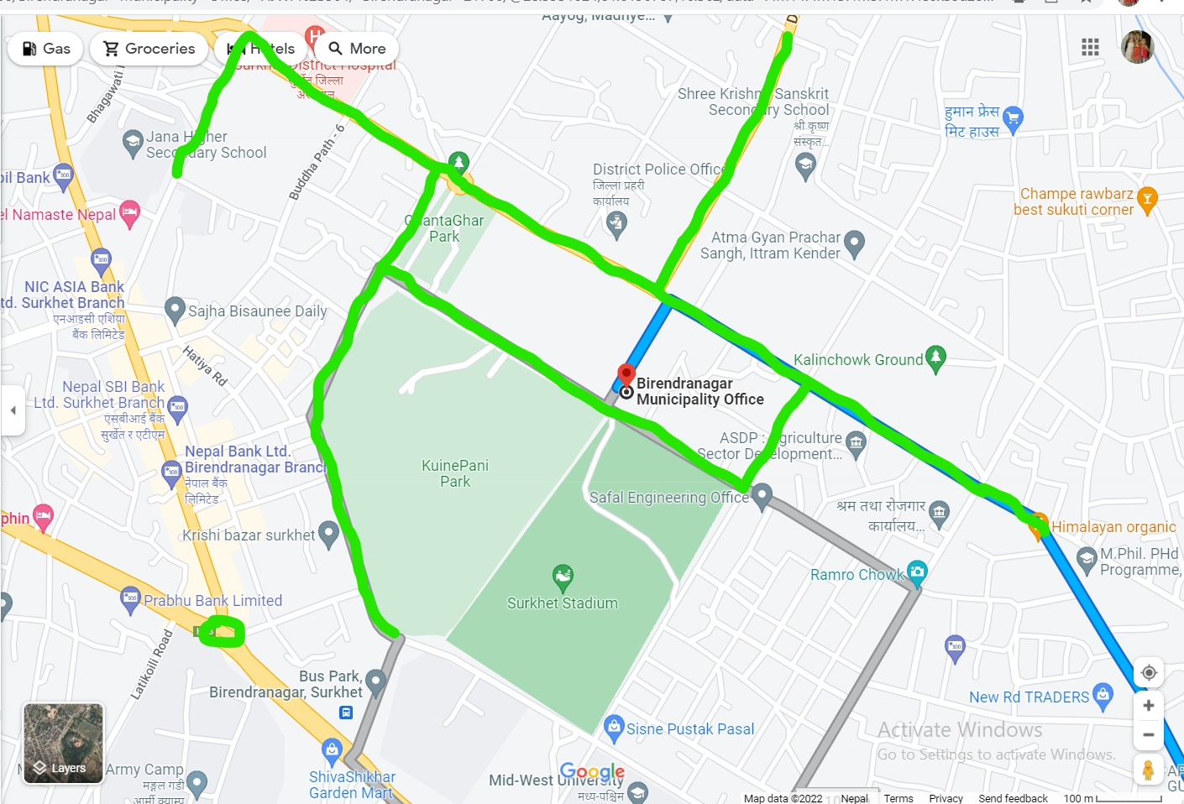
Figure 1 Green highlighted areas are the location for plantation, waste bin and resting station installation at ward 6, 7 and 8.

Coordination mechanisms

Tayar Nepal
ISS
BNNP
Team Leader
Wash expert
Plant expert / GESI and Reporting Officer
Civil Engineer
Program Implementation

Progress update

Plantation:
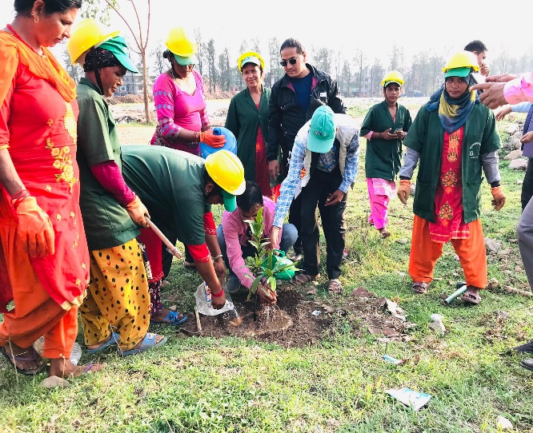
On the base of Objective 1 "To promote climate resilient Birendranagar Municipality through plantation for contribution on climate change and biodiversity." ISS had started plantation from May 15, 2022. ISS had conducted Inauguration of plantation in May 15, 2022 at ward 8, Kalinchowk , Birendranagar Municipality in the presence of Mr. Dev Kumar Subedi Mayor of BNNP, Mr. Mun Bdr Rawat DFO Officer, Mr. Prakash Paudel Head of Environment Department, Mr. Dhruba Chapai , Ward -8 chairperson, Mr. Rajesh Soni, Field Coordinator TAYAR Nepal, Mrs Siya Karki Pradhan , President of Inner Wheel club Surkhet Valley and her team, Mr. Bikram Thapa, Mega Bank Branch Manager, Media and ISS Staffs. The events was started planting trees by Mayor Dev Kumar Subedi. Along with that, from private sector Mrs Siya Karki Pradhan, President of Inner Wheel club Surkhet Valley and her team & Mr. Bikram Thapa, Mega Bank Branch Manager were interested to adopt some plants.
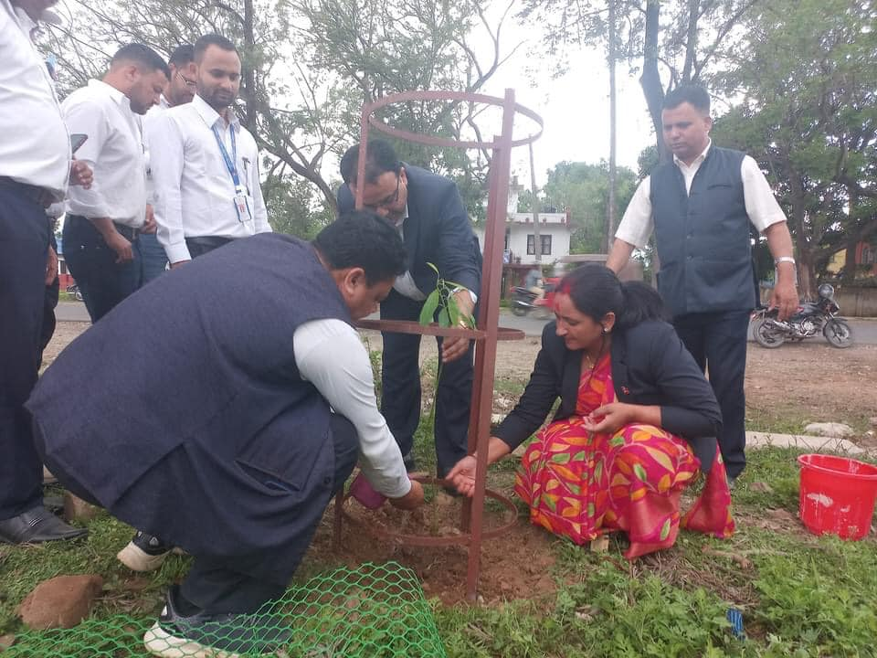

On 12th day of the remembrance of Late Revenue Officer Mr. Hriday Dhakal of Birendranagar Municipality, the staffs of Birendranagar Municipality along with Mayor and deputy Mayor of Municipality had planted 50 plants at ward 8 on the way to Ghataghar to Municipality.

On the environment day ( Jun 5, 2022), around 100 plants were planted in ward 7 in the presence of Mayor Mrs. Mohanmaya Dhakal, Deputy Mayor Mr. Nilkantha Khanal, Head of Administration , <r. Narhari Tiwaree and other staffs from municipality, ISS and Inner Wheel Club of Surkhet Valley. On the day, Inner Wheel Club of Surkhet Valley had adopted 50 plants. It will take responsibilities to take care of the plants. On Jun 25, 2022, Mega Bank Sukhet had adopted 30 plants from ward 6.

The name of plants planted are Mango stick, guava, Neem, Avogado, Mango, Jamun etc For the protection of plants , plants guard are also installed in the same day.

From this activity 15 no of people from poor and marginalized group received green job opportunity to plant and installing the 1000 plants guards. This activity is supporting to promote green in the city as well provided green job opportunity.

Quality assurance plan( Table no 5 )
S.N. | Activities | Indicators | Target | Data source | Frequency | Responsible | Reporting
1 | Procurement & Installation
1.1 | Tree Plantation Cost | # of plants planted with safeguard | 1000 | Monitoring report, periodic report | Start after the feasibility study | Plant expert, Team leader, engineer | GESI and reporting officer
1.2 | Waiting Station | # of waiting station installed | 20 | Monitoring report, periodic report | 2nd month of project start date | Civil engineer, Team leader, focal person from Tayar | GESI and reporting officer
1.3 | Dustbins ( 3 dustbin in one set ) | # of set of dustbin installed with stands | 100 | Monitoring report, periodic report | 3rd month of project start date | Wash expert, team leader and focal person from Tayar Nepal | GESI and reporting officer
2 | Orientation to Tole Development Committee | # of event and participant | 1 | Event and periodic report | First month of project start date | Team Leader, Wash expert | GESI and reporting officer
3 | Joint Monitoring Visit | # of event and participant | 2 | Monitoring report | At the mid and end of the project | Team leader | GESI and reporting officer
4 | Meeting on development of Operation and Maintenance Guideline/Plan for Municipality | # of guideline developed, # of event and participants | 2 | Minute, periodic report | 3rd month of the project start | Team leader, consultant
5 | Assessment | # of event | 1 | Assessment report | Beginning of the project | Team leader, Representative from Tayar Nepal and Municipality | GESI and reporting officer
6 | Meeting with Tole Development Committee | # of event and participant | 10 | Minute, periodic report | Last month of the project | Team leader and Wash expert | GESI and reporting officer
7 | Program review meeting | # of event and participant | 2 | Minutes and periodic report | At the mid and end of the project | Team leader | GESI and reporting officer

Private sectors Involvement:
This program is focusing on involvement of Private sectors for sustainability, such as:
ISS has worked with Tayar Nepal team to develop strategy and methodology to engaged private sectors for sustainability of project activities. ISS worked with local private sectors and develop strategy to engage them in activities. ISS develop and signed the memorandum of understanding with private sectors for repair, maintenance and operation of waste collection bin, resting station and plantation. ISS engaged and signed MoU with following key local stakeholders.
- Inner Wheel Club of Surkhet Valley
- Mega Bank Ltd Surkhet Branch
- Irish Dance and Fitness Center
- Ratriya Madhyamik Bidhyalaya

Commodity | Private sector | Responsibilities
Plants | Inner Wheel Club Surkhet, Mega Bank Surkhet, Peace Land Guest House, Gurukul Montessori | monitoring, Watering, composting and maintenance of plant guard

S.N. | Private sector | Number of plants
1 | Inner Wheel Club of Surkhet Valley | 50
2 | Mega Bank Ltd Surkhet Branch | 27
3 | Irish Dance and Fitness Center | 46
4 | Ratriya Madhyamik Bidhyalaya | 30

ISS has accomplished key activities related to Private Sector Engagement:
- Conducted coordination meeting with private sector for waste collection, resting station and plantation.
- Private sectors agreed to support on collection of waste, repair and maintenance.
- ISS prepared sustainability plan for municipality with engagement of private organization.
- ISS signed Memorandum of Understanding with private sectors with involvement of municipal authority.

Next Priority:
- Monitoring visit
- Review meeting

Challenges and way forward
- Drought for long time, plantation was stopped for few days for the suitable environment of plantation.
- Damage of plant and plant guard by vehicle and roadside animals.
- 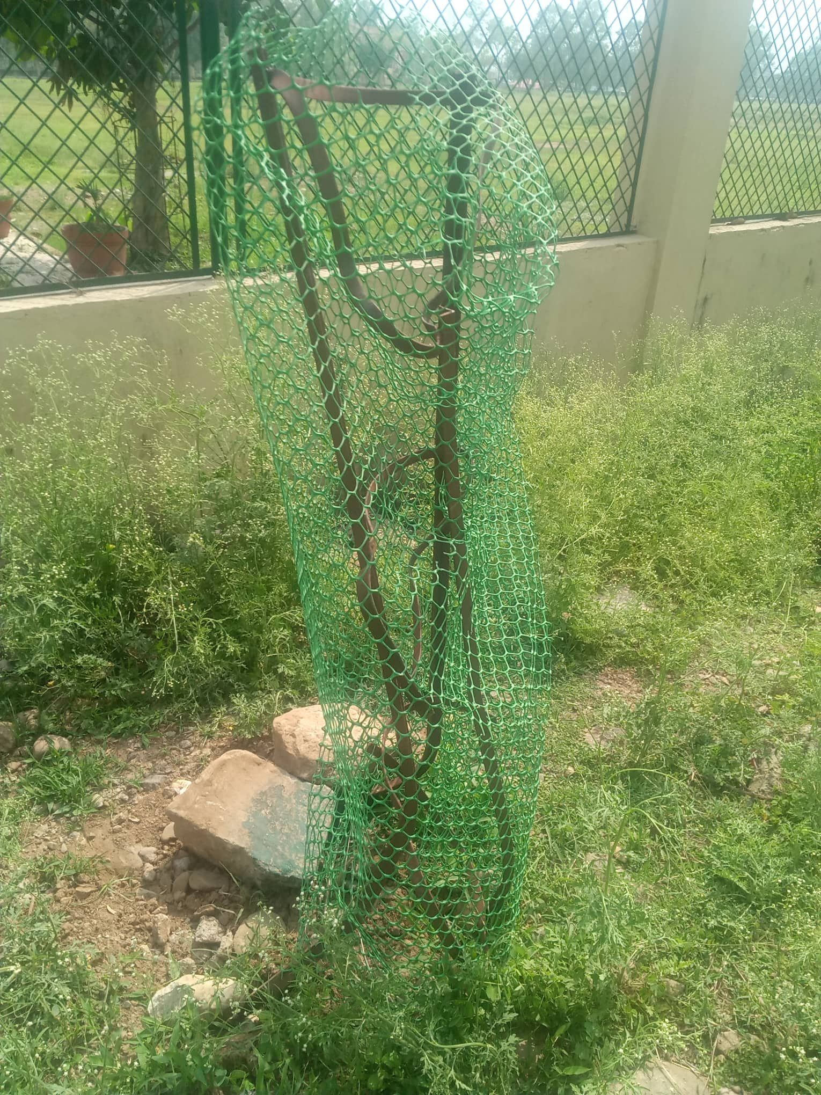
Figure 2 Plant near by Municipality hit by the vehicle.

Annex :
Areas and types of plants:
Ward | Areas | Types of plant | Remarks
6 | From Ghantaghar chowk to Buspark ( Right side ) | Flowering plant, Herbal Plants
6 | From Ghantaghar chowk to Buspark ( Left side ) | Fruits plants, Herbal Plants
7 | From District Police Office to Shiwalaye Chowk | Fruits plants, Herbal Plants
7 | From Kalinchowk to Ghantaghar | Fruits plants, Herbal Plants
8 | Industrial areas to Kalinchowk | Flowering and fruit plant, Herbal Plants

111. photos:
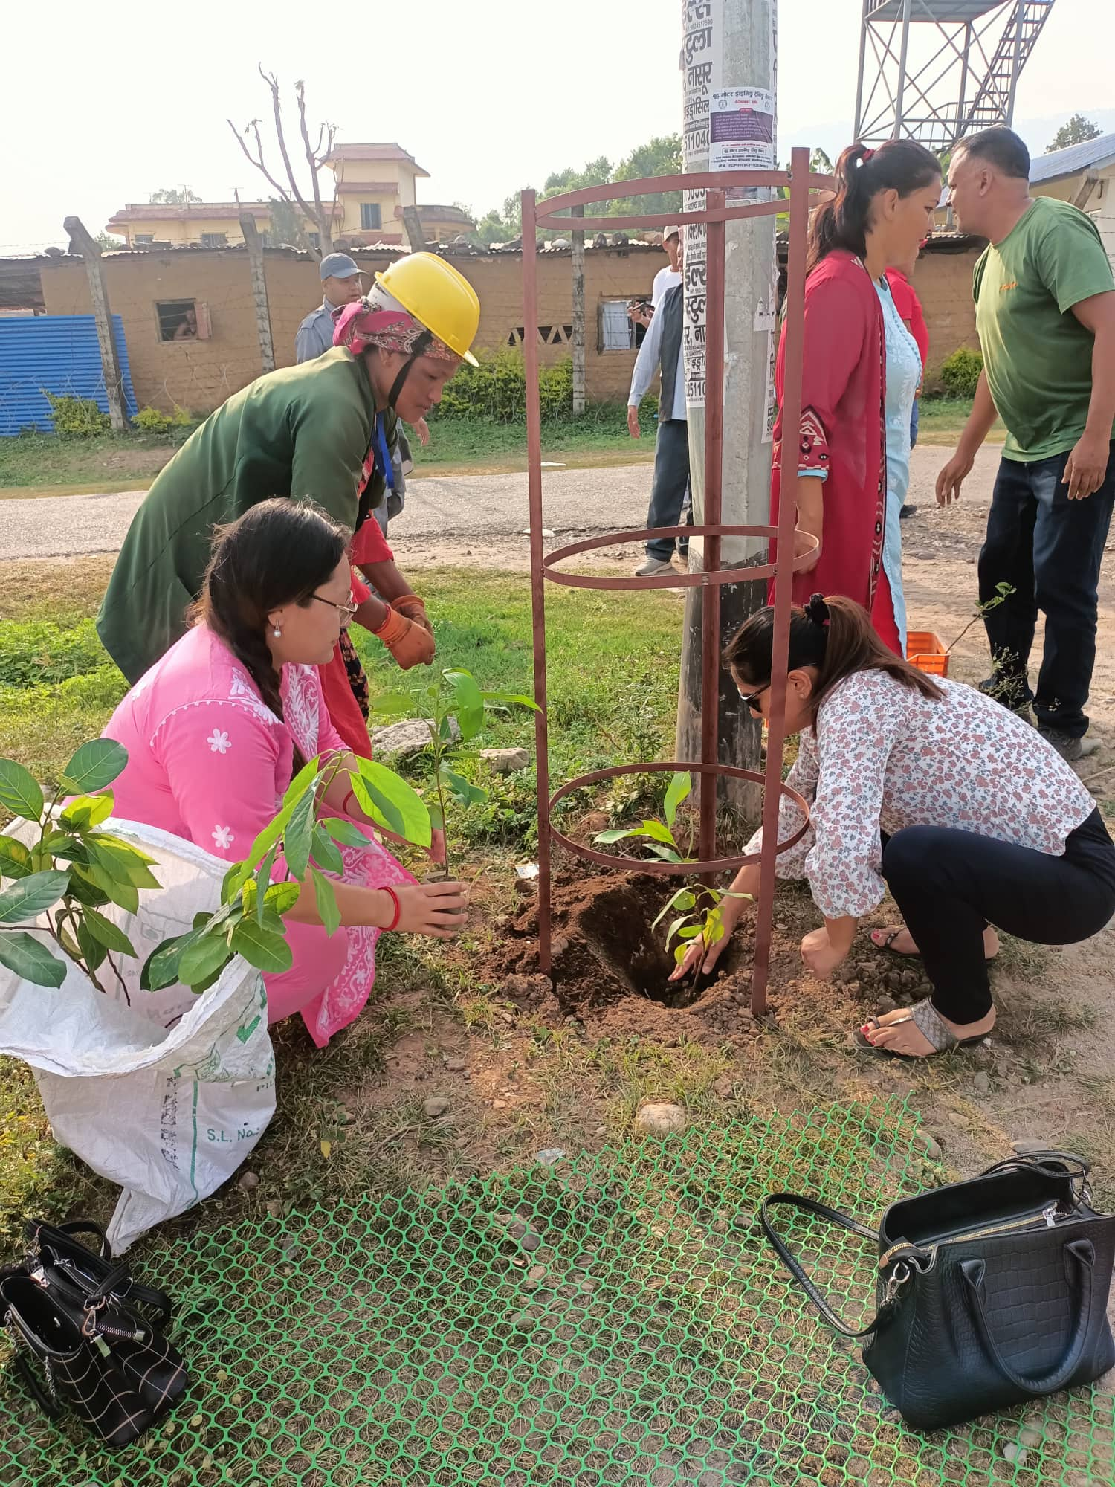  Figure 1 planting adopted plants by Private sector Inner Wheel Club of Surkhet Valley | 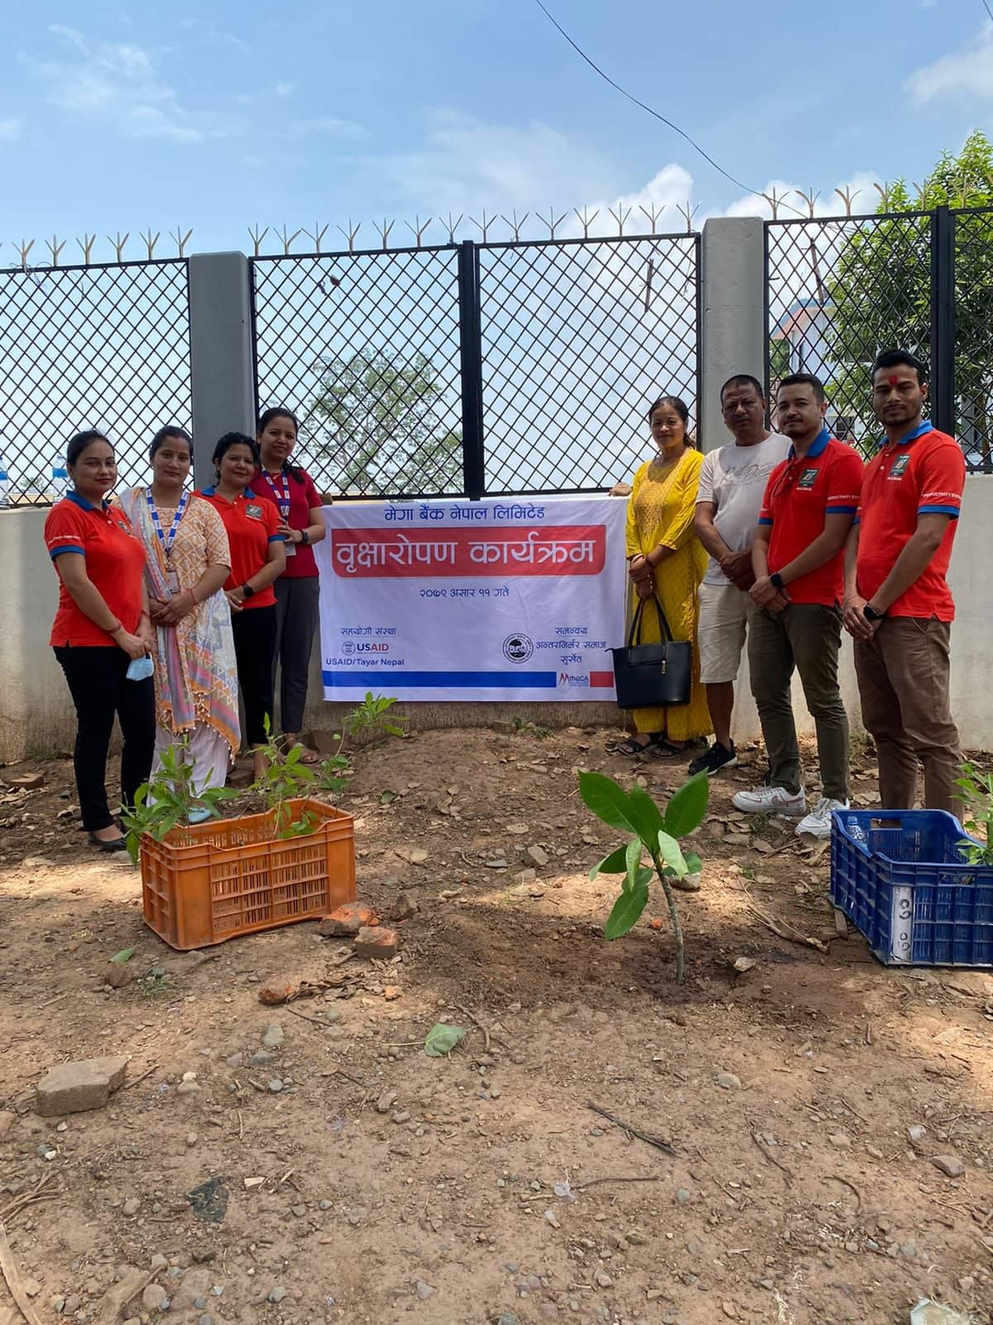  Figure 2 Planting adopted plants by Private Sector Mega Bank Surkhet

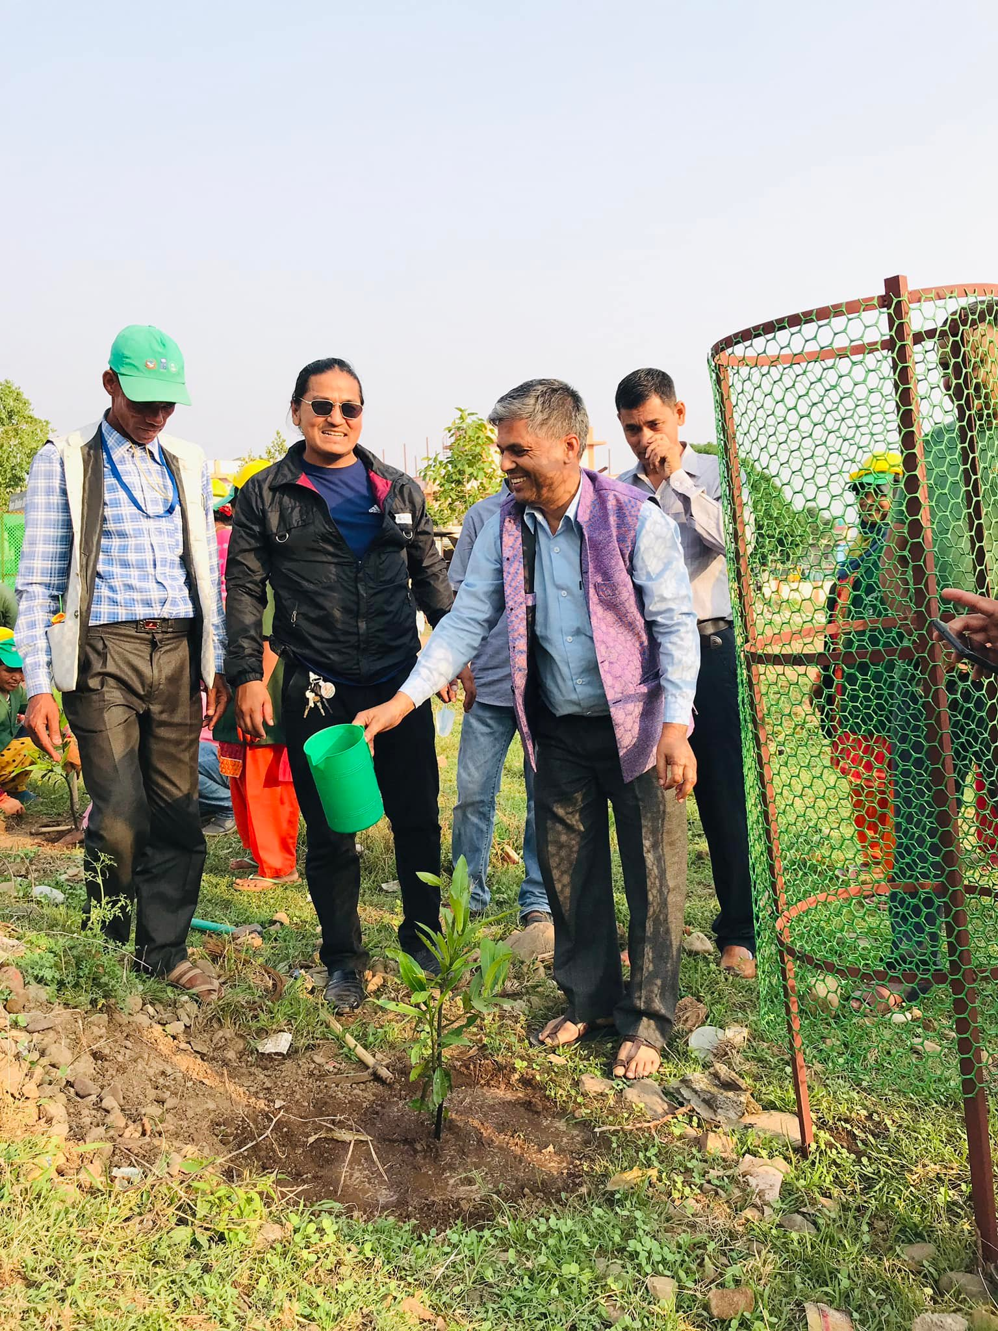  Enaugration of plantation by Mayor Dev Kumar Subedi | 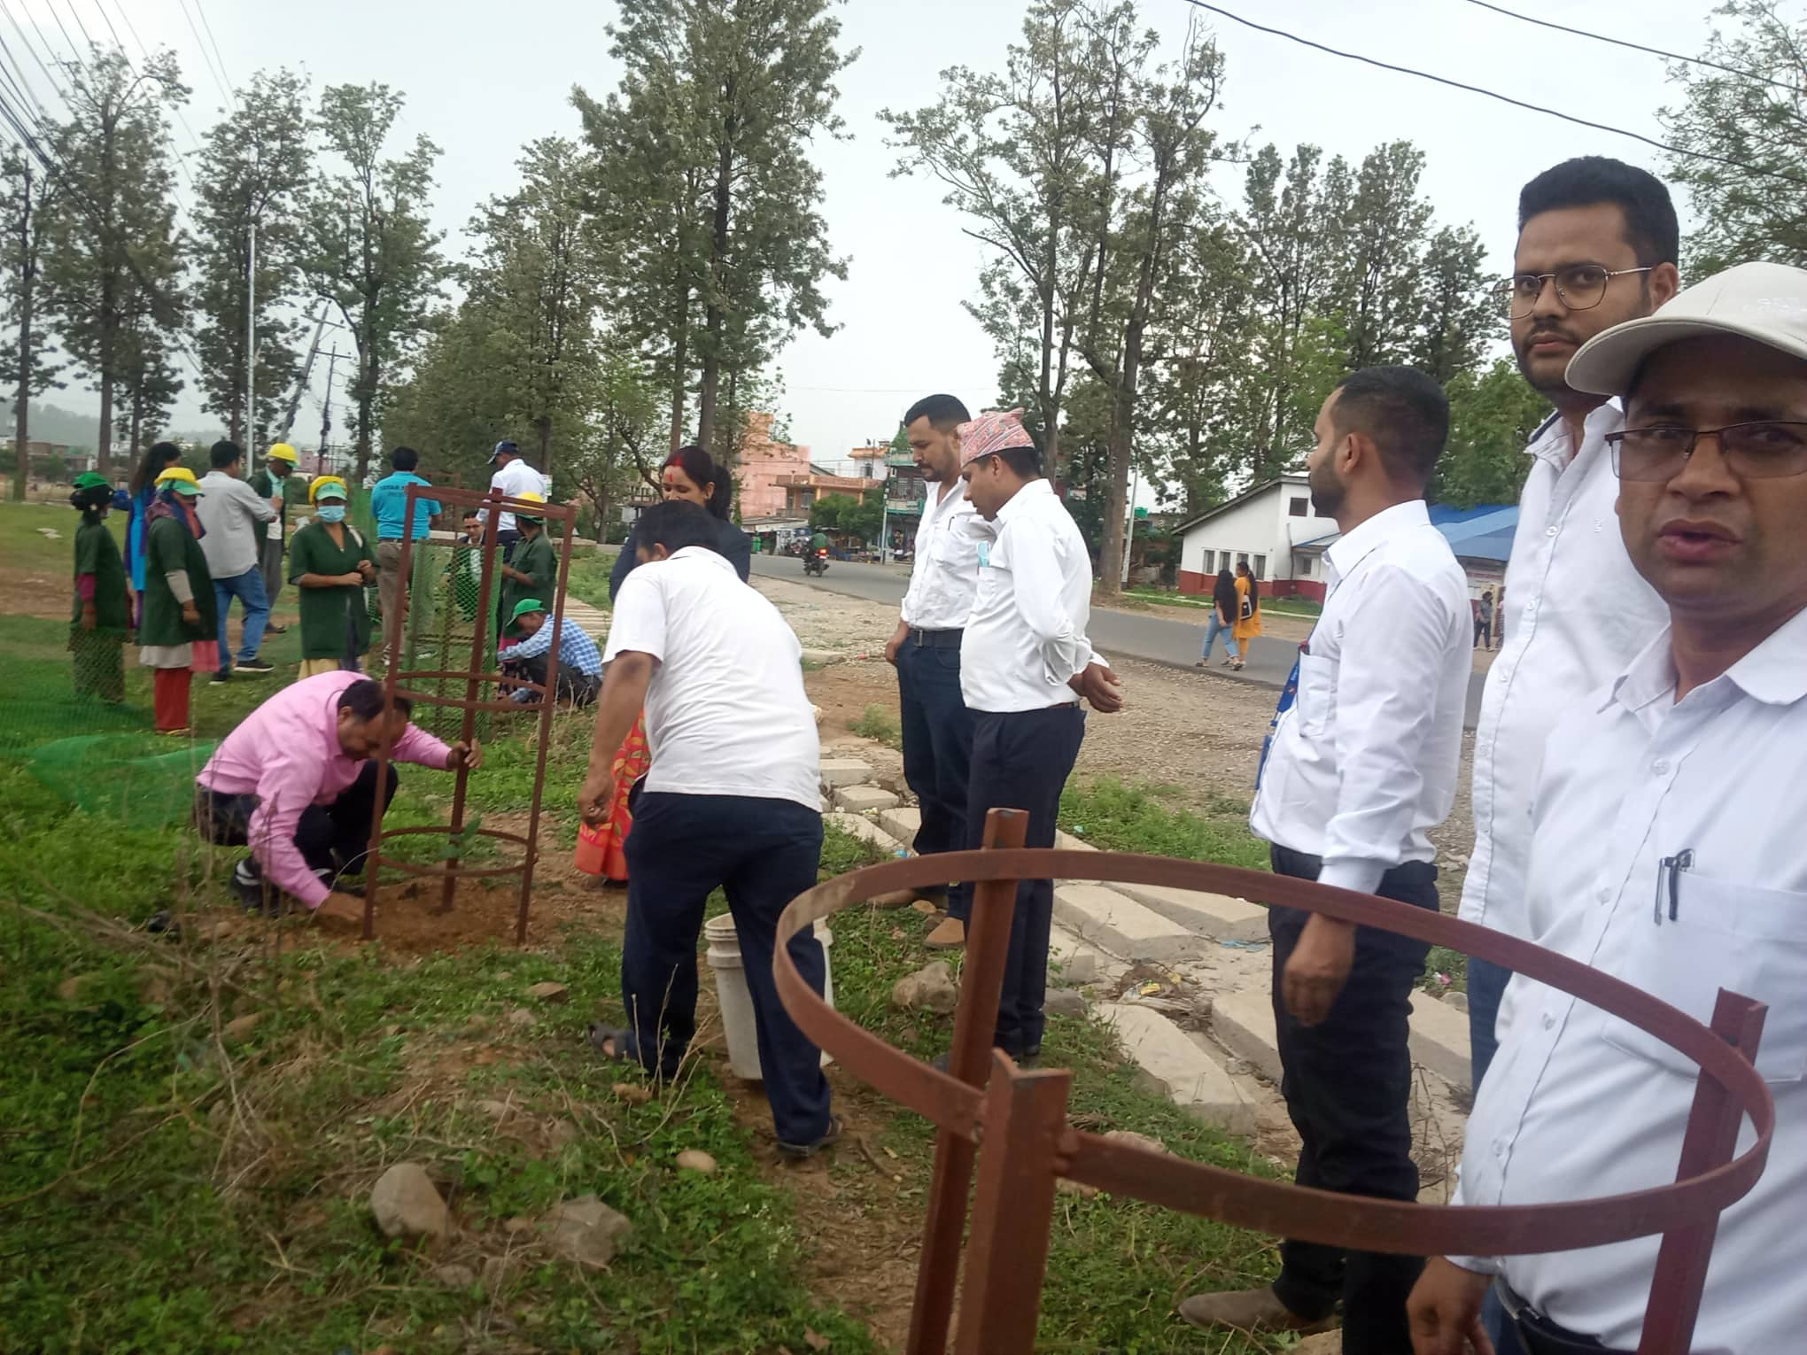  Figure 3 Plantation in the 12th day memory of Late Hridaya Dhakal, Revenue Officer, BNNP

